Sylhet Engineering College  
  
Experiment No : 01  
  
Name of the Experiment: STUDY OF DIODES AND ITS APPLICATIONS.

|  |
| --- |
| Remarks: |

Submitted To : Submitted By :

MD Shahadat Hossain Parvez Rejoun Khan Rajo

Lecturer of EEE Dept:EEE

Sylhet Eng. College Reg:2015338529

Problem -1  
 V-I characteristics of Diode 1N4001 .  
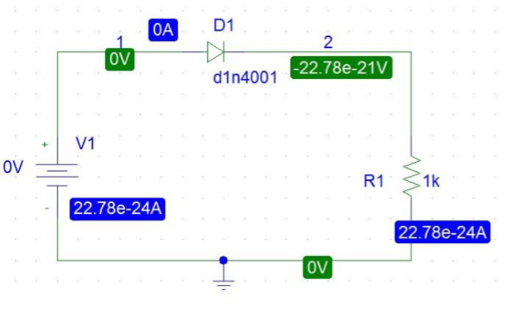  
 Fig:(1) DC analysis of D1N4001  
Procedure:  
1.First need to Drow the circuit figure.  
2. determining the I-V characteristics a DC Sweep of V1 from –5V to +10 volts will be needed. Set the increment of V1 to 0.1 volts in linear sweep mode.  
3. Run the simulation. Obtain I-V characteristic of the diode in the probe.  
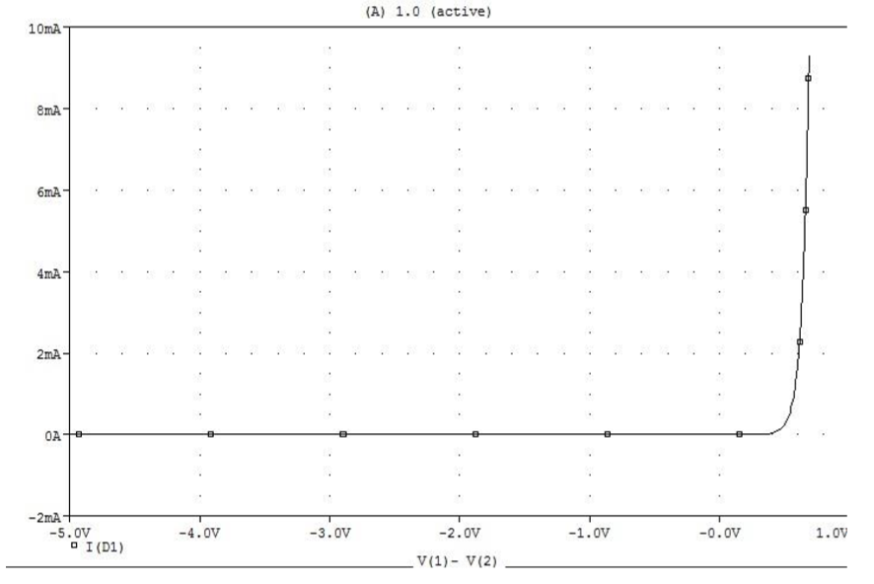 Fig of graph  
For getting Reverse saturation current and breakdown voltage For getting reverse saturation current and breakdown voltage , the dc sweep was changed . The new range applied was -100v to 10v.  
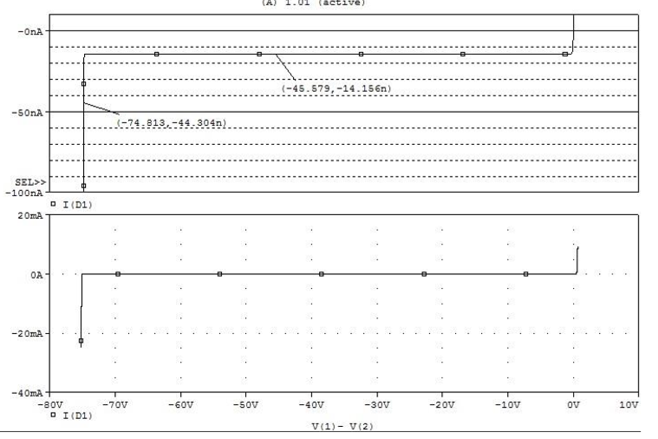  
  
Problem 2: Clipper circuit.  
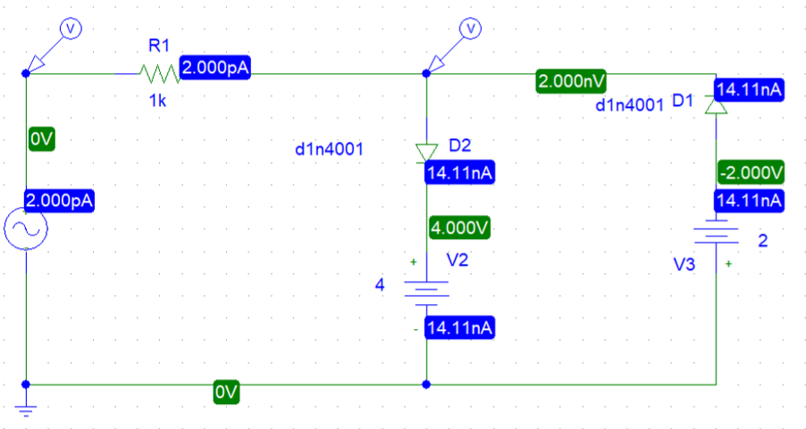  
 Fig(2):Clipper circuit.

Procedure:  
1.First need to Drow the circuit figure.

2. For determining the input vs. output characteristics V1 is set to 1KHz and 10V (peak). Connect voltage markers as indicated in Fig. 2. Set transient analysis upto 5m.

3. Run the simulation.

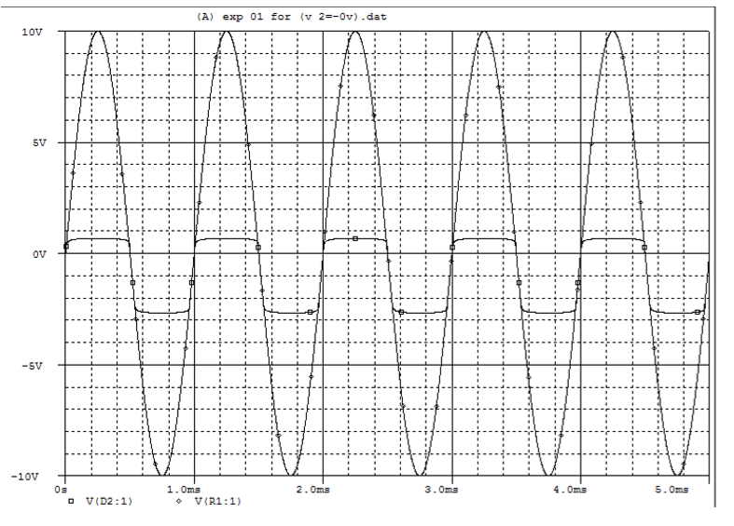  
 Graph For V2=0

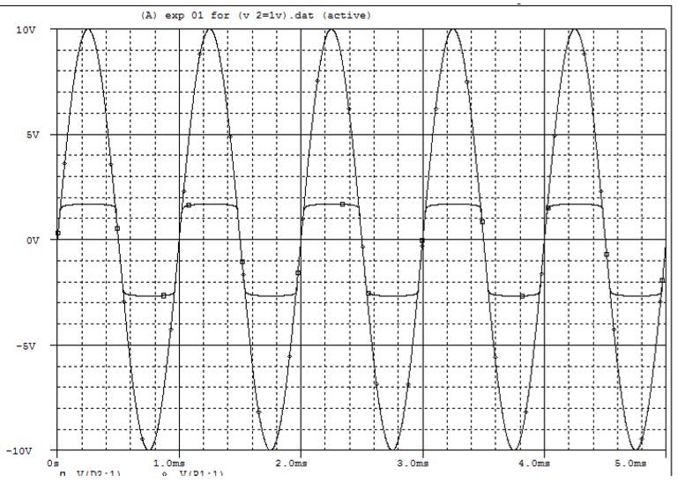  
 Graph For V2=1  
problem 3: Clamper Circuit.  
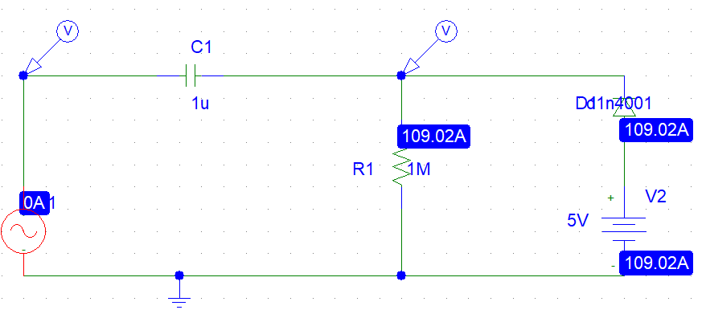

Fig.3. Clamper Circuit .

Procedure:

1. 1.First need to Drow the circuit figure.

2. Here, for determining the input vs. output characteristics V1 is set to 1KHz and 10V (peak). Set R1 = 1M, C1 = 1F and V2 = 5V. Connect voltage markers as indicated in Fig. 3. Set transient analysis upto 5ms.  
3. Run the simulation.  
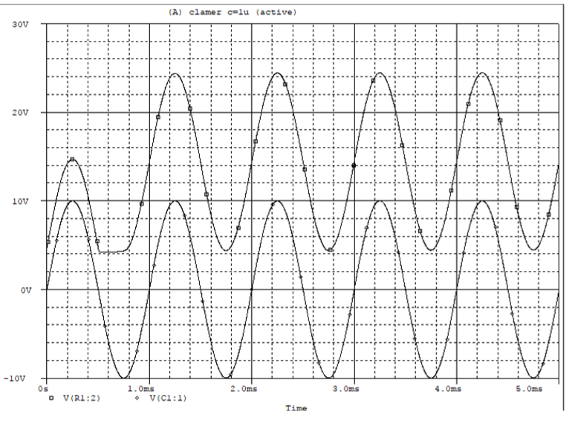  
 for c=1uF  
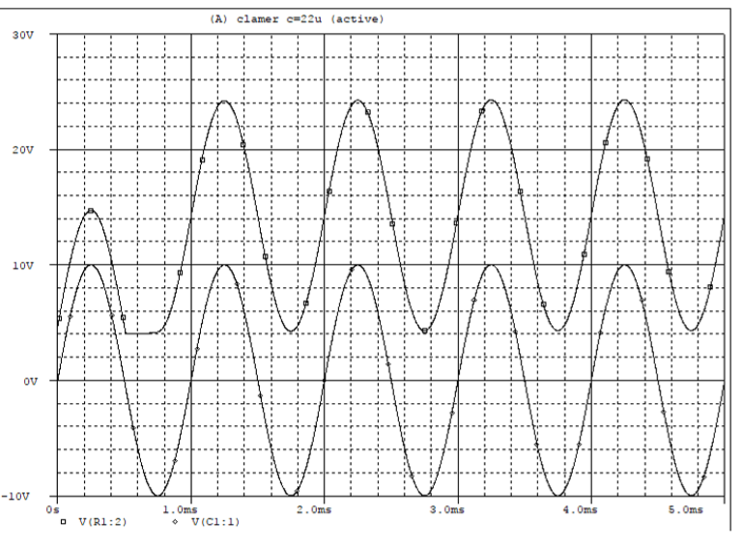  
 For c=22uf

Problem 4 : Rectifier circuit.

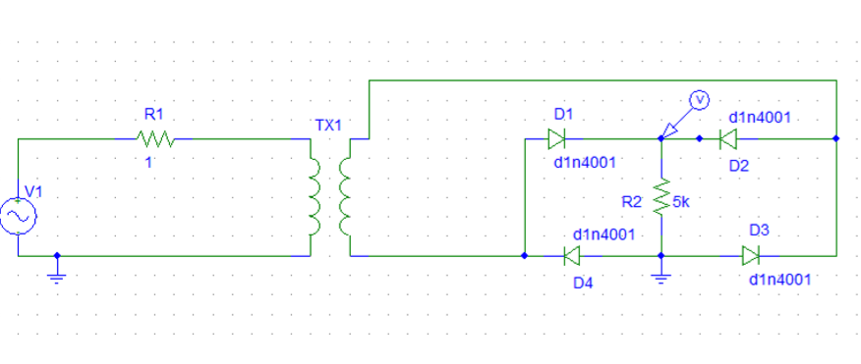

Fig.4. Diode bridge rectifie

Procedure:

1. 1.First need to Drow the circuit figure.
2. TX1 is a transformer having part name “XFRM_LINEAR”. Double-click it and set L1 and L2 to 100mH. Set V1 to 10V, 50 Hz.
3. Run Simulation.  
   